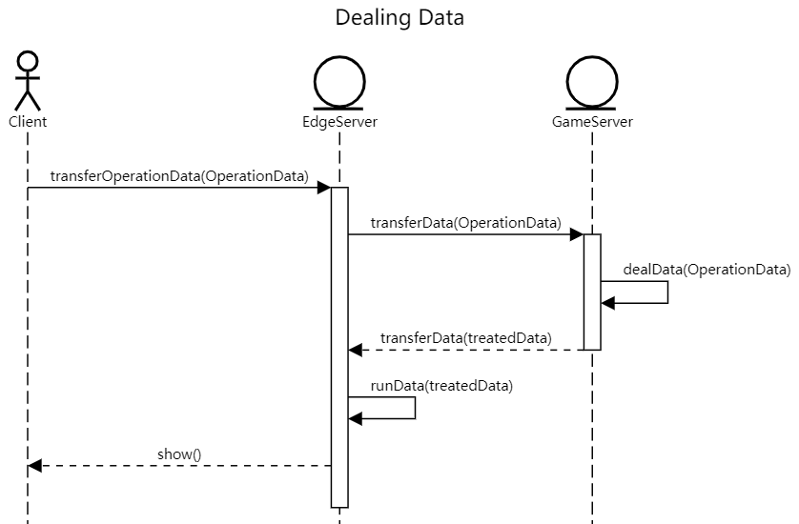
Player do an operation on the client and client send user’s operation data to edge server, then edge server transfer operation data to game server. The game server deals the operation data and turns it into treated data which can be run by edge server. Then edge server receives the treated data and run it to display game to clients.
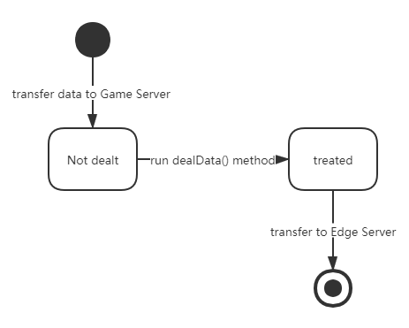
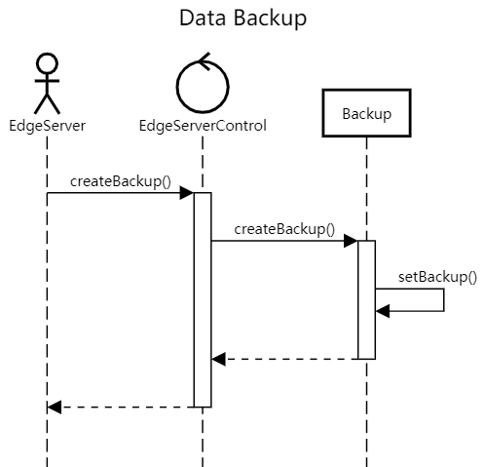
Edge server wants to backup game status, send request to edge server control, then control activate the interface that create data backup then store backup in edge server class.

